**Lunar Folding**

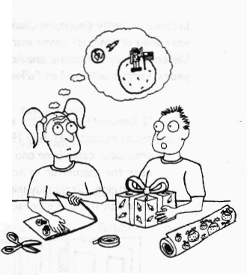

Lizzie and Philie were wrapping

Christmas presents.

Lizzie, if you continue to fold that piece of paper, it will reach the moon,’ said Philie.

Don’t be so ridiculous,”

replied Lizzie.

Explain what Philie meant by this.